Madeleine Monfort

3/23/16

COP4600

Project 1b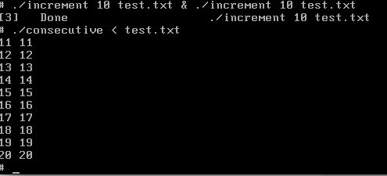

The above picture shows running two increments (one in background, one in foreground). As is shown, it produces a race condition immediately. In fact, I think every new line for this is repeated.

The critical section is the opening-reading-closing of the file and the opening-writing-closing of the file.

In my version of Peterson’s solution, I have an enter_region and exit_region functions which go around the critical section inside the for loop incrementation. My critical section comprises of opening-reading-closing and opening-writing-closing.

The enter_region and exit_region functions contain the logic for locking and checking locks, and then a while loop for busy waiting.

I used the shell script part3.sh from Canvas to test my safe_increment function.

Note: my consecutive.c file reads from stdin. So the input text file must be read as

./consecutive < safe.txt

NOT

./consecutive safe.txt

I have altered the part3.sh script to fit this method.

